Wimygit Test Plan

|  |  |
| --- | --- |
| Application Name | wimygit |
| Application ID | APP_3166 |
| Application Version | NA |
| Application Install Location | App Location on Appcompatsrv Server(\\appcompatsrv\Appcompat\DotNetCore\Apps\WimyGit) |
| Source Install Location | https://github.com/zelon/wimygit |
| Application Priority | P5 |
| Technology | WPF |
| .NET Version | .NET Core 3.0 |
| Client Supported | Yes |
| Deployment | XCopy |
| Design Times usage (hours) | NA |

# History Log

|  |  |  |  |
| --- | --- | --- | --- |
| **No.** | **Date** | **Comments** | **Author** |
| 1 | 04/28/2020 | Create the test plan | Xiaoxiao |
|  |  |  |  |
|  |  |  |  |

# Configurations

Following configurations are tested in the manual phase:

|  |  |  |  |
| --- | --- | --- | --- |
| Config # | Platforms + NetFx | Target To | Comments |
| 1 | Windows 10 X64 + .NET Core 3.0 | Default version | Design test plan |
|  |  |  |  |

Table of Contents

History Log 1

Configurations 1

Summary 2

Pre-requisite 2

Brief Introduction 2

Installation or Deployment 2

Uninstallation 2

Scenarios 2

Scenario 1: Test New PDF 2

Issues 6

# Summary

Following table shows scenarios tested for the app and their pass/fail status.

|  |  |  |  |
| --- | --- | --- | --- |
| Items | Test Case Title | Technology Description | Config #1 |
| Install | -- | -- | Pass |
| Uninstall | -- | -- | Pass |
| Look and feel | -- | -- | Pass |
| Performance | -- | -- | Pass |
| APP_3166_001 | Test Pages |  | Pass |
| APP_3166_002 | Test function |  | Pass |
| Issues | NA |  | NA |
|  |  |  |  |

# Pre-requisite s

|  |  |  |
| --- | --- | --- |
| **No.** | **Name** | **Comment** |
| 1 | Dotnet sdk | Version 3.0 |
|  |  |  |
|  |  |  |

# Brief Introduction

# Installation or Deployment

Copy all files from \\appcompatsrv\Appcompat\DotNetCore\Apps\WimyGit

to %APP_CLIENT_ROOT%\SciChart.Wpf.UI folder.

# Uninstallation

# Scenarios

## Scenario 1: Test Refresh

**Case ID: APP_3166_001**

**Clean Environment:**

Delete “%APP_Client_SCRIPTSDIR%\AdditionFiles\BluebeamRevu\Document1.pdf” file.

Delete “%APPDATA%\Bluebeam Software\Revu\18” folder.

Copy XXX to XXX.

**Test Steps:**

1. Launch appliciaton from "C:\Uers\Appcompat\Desktop\appcompat\application\WimyGit\WimyGit.exe"
2. Drag wimygit source code from local computer into here

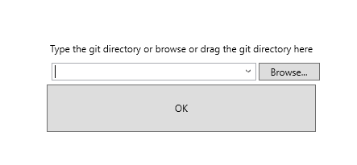

1. Add annotation in ConfigFileController.cs class in Config folder
2. Click “New PDF” item.
3. **Verify**: the “Highlinght” tool exists in “Recent Tools” panel.

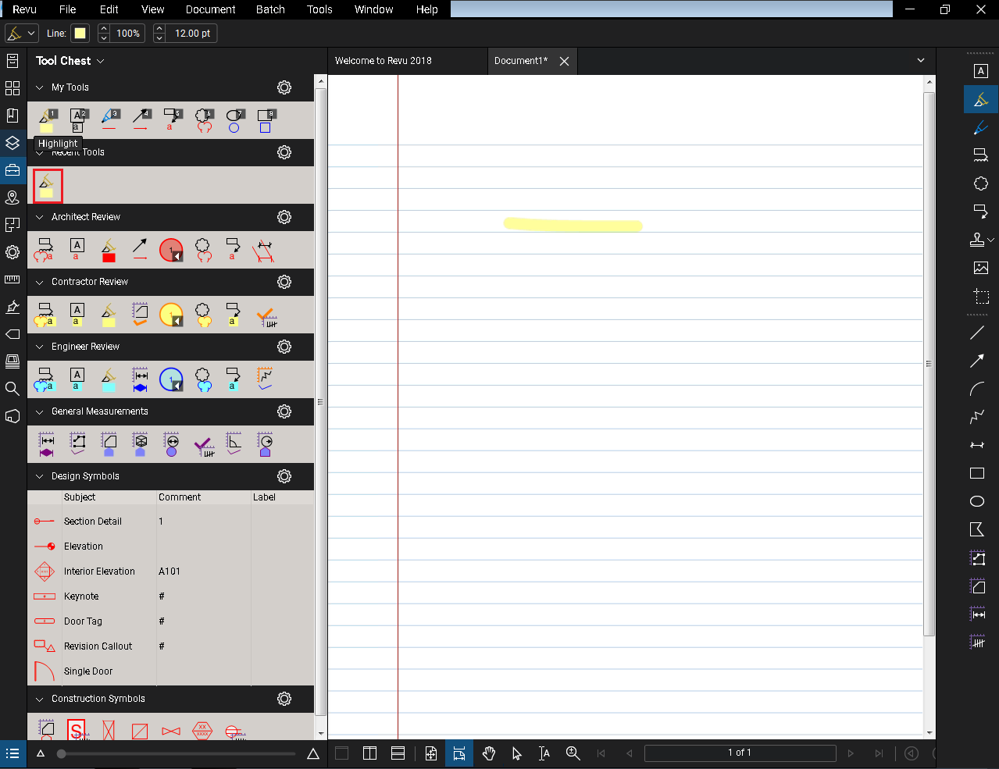

1. Click “Close” button to exit this application.

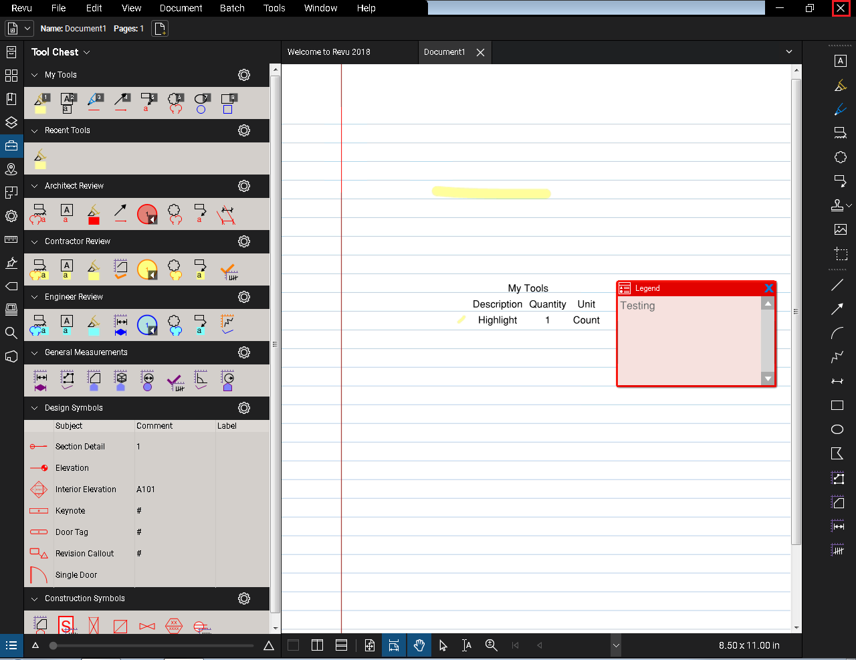

# Issues

No issue.